**Create The IBM Watson IoT Platform And A**

**Device**

|  |  |
| --- | --- |
| Date | 09 November 2022 |
| Team ID | PNT2022TMID08488 |
| Project Name | GAS LEAKAGE MONITORING AND ALERTING SYSTEM FOR INDUSTRIES |

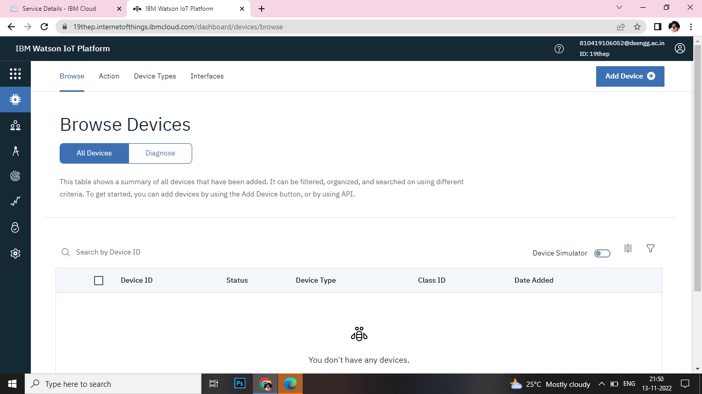

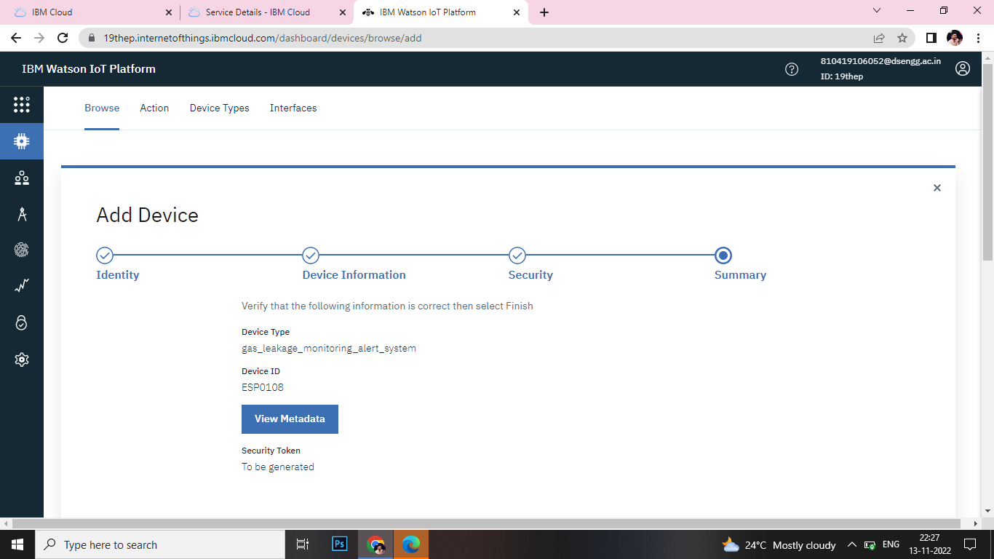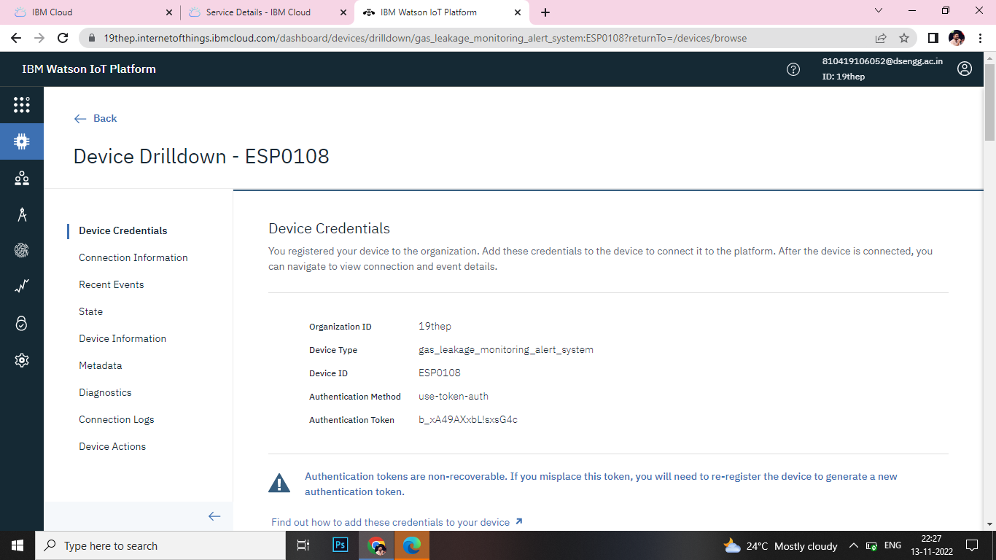

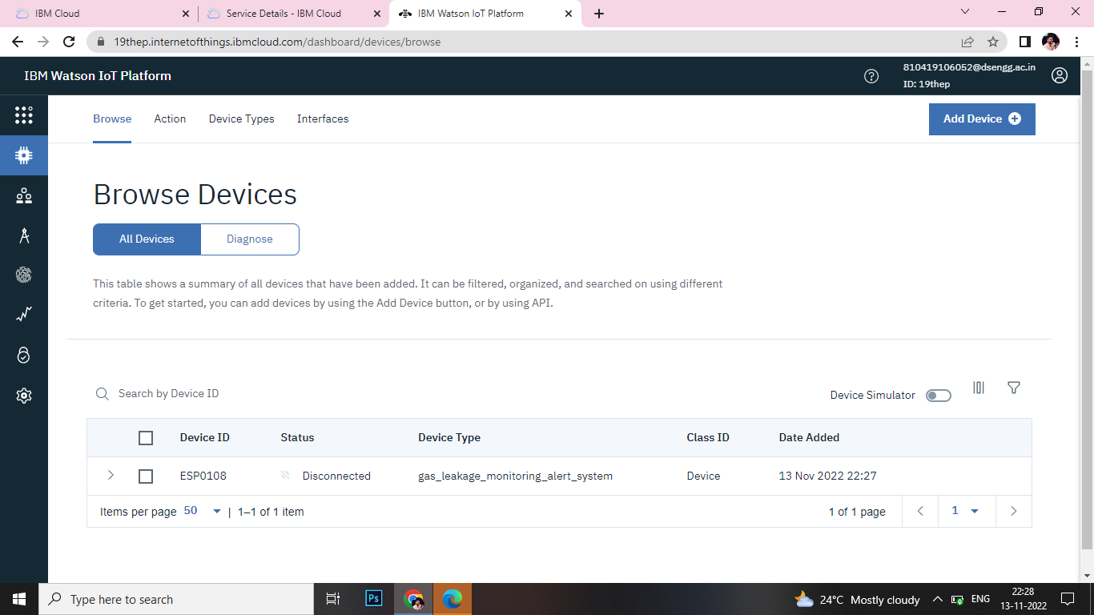

Creating IBM Watson Account and adding a device is successfully completed